
LOYOLA COLLEGE (AUTONOMOUS), CHENNAI – 600 034
B.Sc. DEGREE EXAMINATION – MATHEMATICS
SECOND SEMESTER – APRIL 2011

MT 2501/MT 2500 - ALGEBRA, ANAL.GEO & CALCULUS - II

Date : 08-04-2011 Dept. No. Max. : 100 Marks
Time : 9:00 - 12:00

PART – A
Answer ALL questions: (10 x 2 = 20)
1. Evaluate 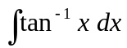.
2. Evaluate 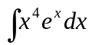.
3. Solve: 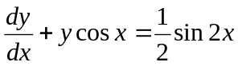.
4. Solve: 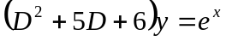.
5. Prove that the series 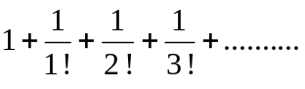is convergent.
6. Test for convergency the series 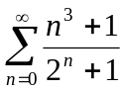.
7. Find the general term in the expansion of 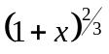.
8. Prove that the coefficient of 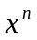in the expansion of 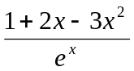 is 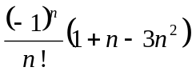.
9. Find the equation of the sphere which has its centre at the point 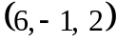 and touches the
plane 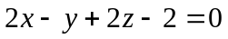.
10. Find the distance between the parallel planes 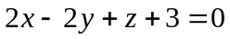and 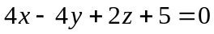
PART – B
Answer any FIVE questions: (5 x 8 = 40)
11. Prove that 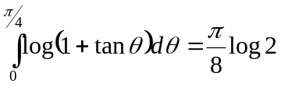.
12. If 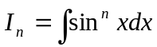( n being a positive integer), prove that 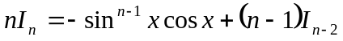.
Also evaluate 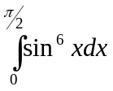 and 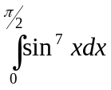.
13. Solve: 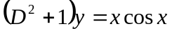.

14. Solve 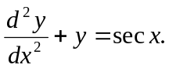
15. Test for convergency and divergency the series 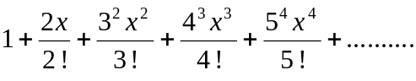
16. Show that the sum of the series 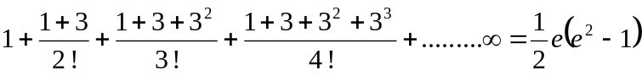.
17. Show that if 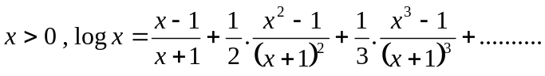

18. Find the equation of the plane passing through the points
.

PART – C
Answer any TWO questions: (2 x 20 = 40)
19. a) Evaluate 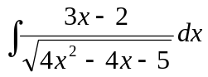 (10 marks)
b) Find the area and the perimeter of the cardiod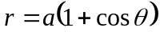 . (10 marks)
20. a) Solve: 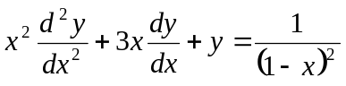. (10 marks)
b) Discuss the convergence of the series 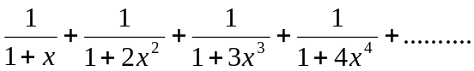 for
positive values of . (10 marks)

21.a) Show that the error in taking 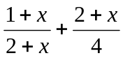 as an approximation to 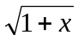 is
approximately equal to 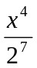 when is small. (10 marks)
b) show that 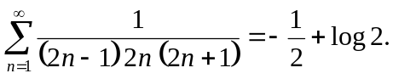 (10 marks)

22. a) A sphere of constant radius passes through the origin and meets the axes in A, B, C.
Prove that the centroid of the triangle ABC lies on the sphere 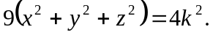
(10 marks)
b) Find the shortest distance between the lines
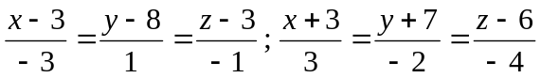.
Also find the equation of the line of shortest distance. (10 marks)

$$$$$$$

